Personal Fitness (MERN) Site

Harrison Spain  
Undergraduate Computer Science Capstone  
Capstone Advisor: Professor Reale  
SUNY Polytechnic Institute  
Spring 2023

# Introduction

The purpose of this project is to create a full stack MERN application that will serve as an interactive business page allowing clients to contact the owner, purchase plans in the form of memberships, view content and maintain a sense of certainty by gaining details about the gym.

To have a working web page the front end, and backend must properly communicate with one another. For example, it is simple to create a component with React and implement routes on the frontend of the project. Once you begin to fetch data from the backend to populate on the given component with the intended data things can get complicated quickly. As you add more libraries and implement changes you must ensure that you are not going to break the project. To avoid running into complications it can be necessary to use some sort of version control system, in this project we use Git. Simply put, Git allows the programmer to make changes and add them bit by bit to avoid breaking the application.

An online presence allows a small business to connect with customers in their local environment. The use of react utilizes components and routes essentially removes wait times between pages which keeps impatient users from navigating away or choosing alternatives. During the plan selection process, the customer enters his or her credentials which are stored into the Mongo database allowing the business owner to have a sense of current and potential customers. The use of a payment API will allow the business owner to manage active customers, and view payment details all in one place.

# Related work

[React](https://legacy.reactjs.org) [2], is a component-based framework that is used to create painless interactive User Interfaces. [Mongo Database](https://www.mongodb.com/what-is-mongodb) [4], also known as MongoDB, is a document database with the scalability and flexibility that you want with the querying and indexing that you need Node js Is an asynchronous event-driven JavaScript runtime, [Node](https://nodejs.org/en/about).js [3] is designed to build scalable network applications. [Express](https://www.simplilearn.com/tutorials/nodejs-tutorial/what-is-express-js) [1] , is a Node.js framework designed to build API's web applications cross-platform mobile apps quickly and make node js easy.

# Method

**Application Flow**

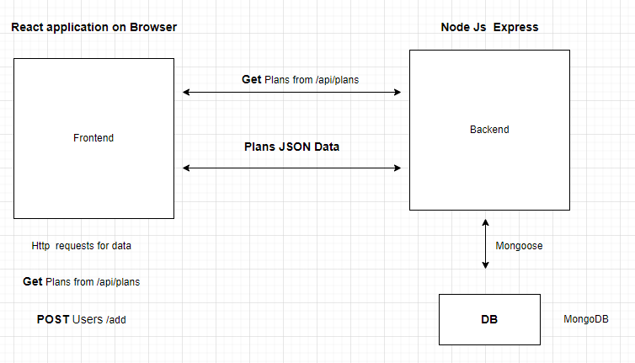

**Http Requests and Using Local Storage**

Get requests are used to fetch the plans form our database and are returned to the frontend react app. We request the plans and populate them into a responsive container utilizing cards imported from React Bootstrap. Post requests are done on the User Details page and its path or route is the /Credentials. Once the customer enters their details their data will be sent to the data base where it is stored as a collection. Saving the form data in local storage allows us to then populate re populate the user’s data to the place order page for confirmation before continuing to process a payment.

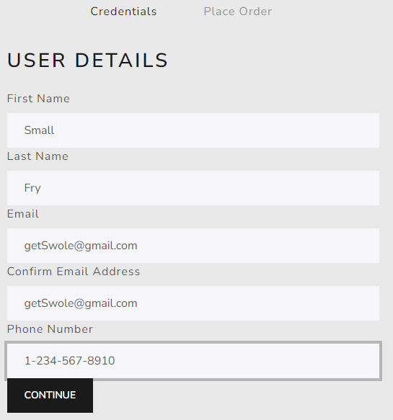 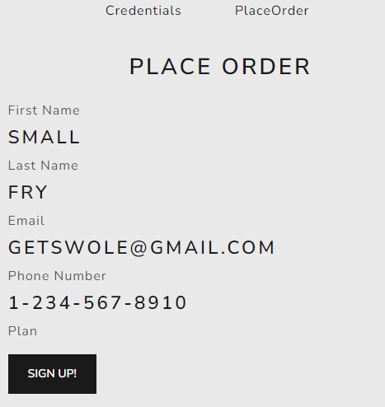

# Results

**User Experience of Bulk Buddies**

The user will begin on the landing page which has a navigation bar comprised of a logo and links to the Plan, Content, and Bio page. If at any point the user would like to return home, they can simply press the logo which is a pretty common practice. The footer consists of a Schedule Consultation link serving as a mail to option along with the Businesses Socials, Copy right notification.

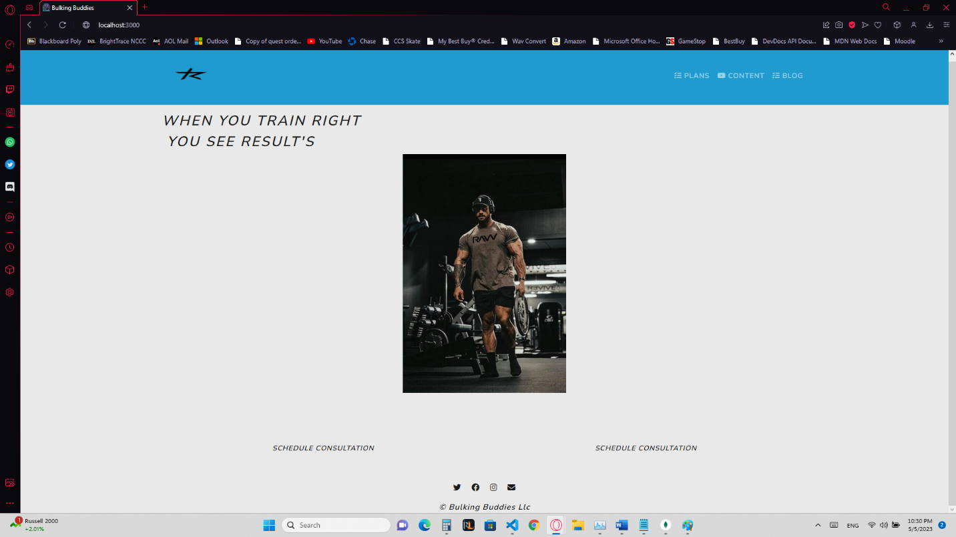

The Plans page consists of the options the user must choose from if interested in purchasing services from the business. When a user decides the plan they are interested in, they will select the Get started button and then be navigated to a 2 step purchasing process.

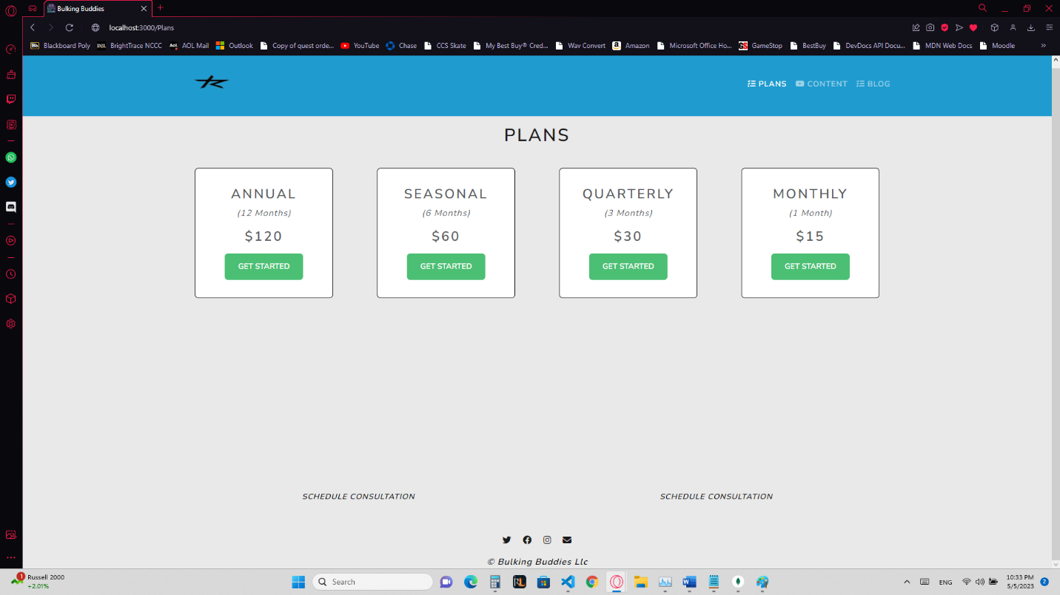

At this point the user has reached step one of the purchasing processes. The user will enter their contact information, and be prompted if the data is inaccurate, E.g., mismatching email. The user is unable to move to step two until properly entering their credentials and selecting the continue button.

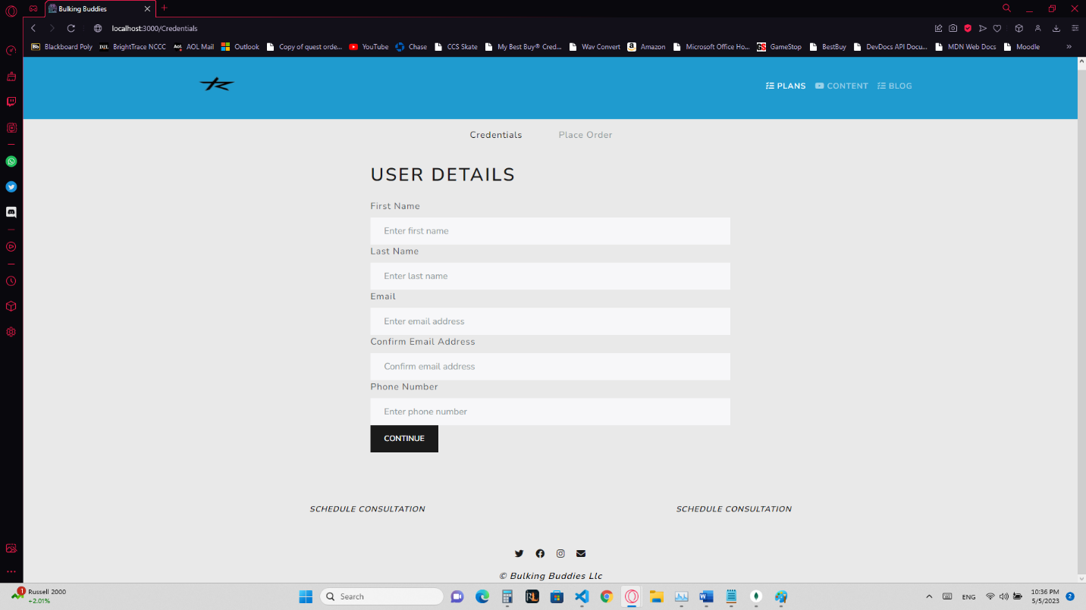

Now that the user has successfully entered their credentials, they are able to move to the second step of the purchasing process. In this step they will have an opportunity to verify their data and when ready, select the sign-up button to be navigated to our selected payment processing API.

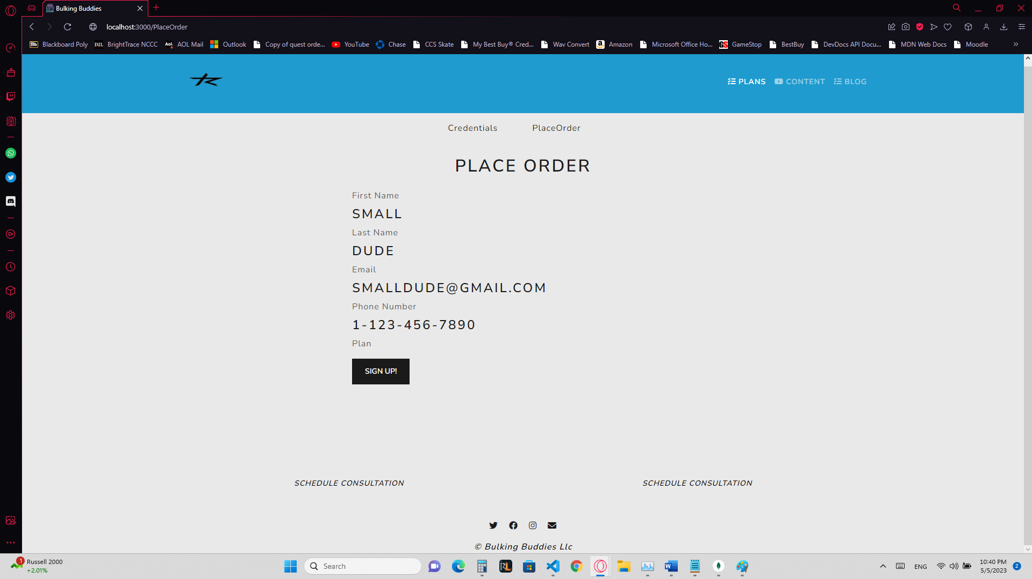

Our Content page consists of videos meant for educating potential and existing customers. Upon navigation to the content page the user will get a list of hand-picked videos intended for the best results. To provide for a better User Interface, the user can select the menu on the side to filter to the given muscle group they are interested in learning about.

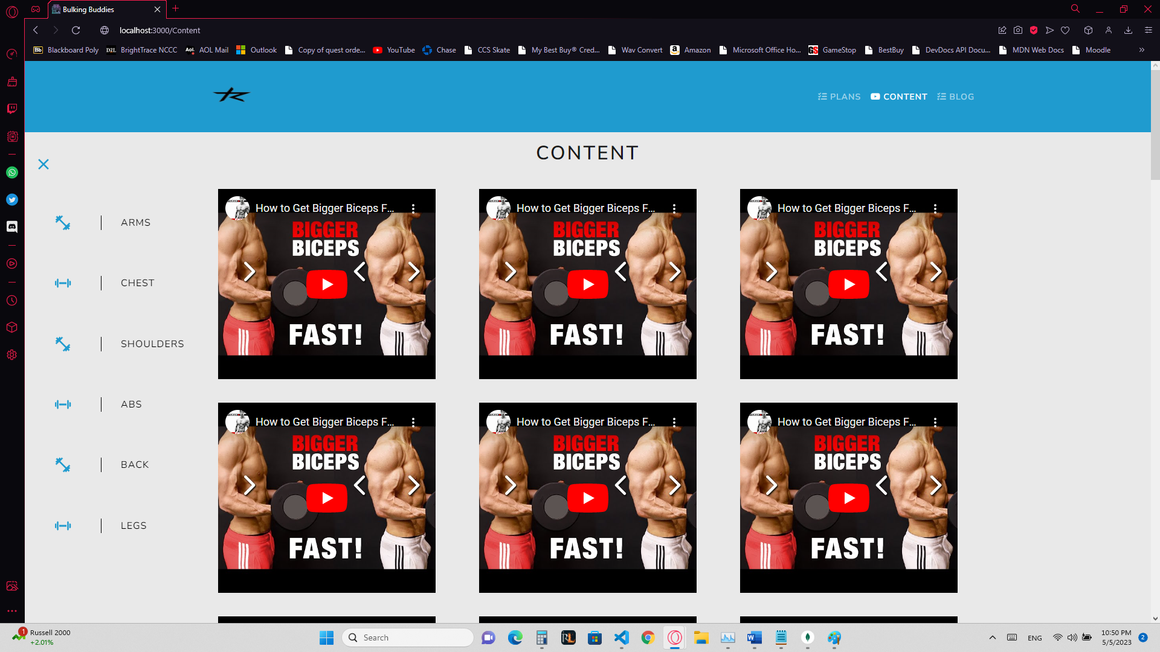

If the user would like to get some more information about the trainer’s gym, and where the will be training they can navigate to the Bio page. This page consists of a sliding gallery providing the user with a sense of security as they can swipe through the pictures of the gym, and at the end get an in depth walk around of the training facility.

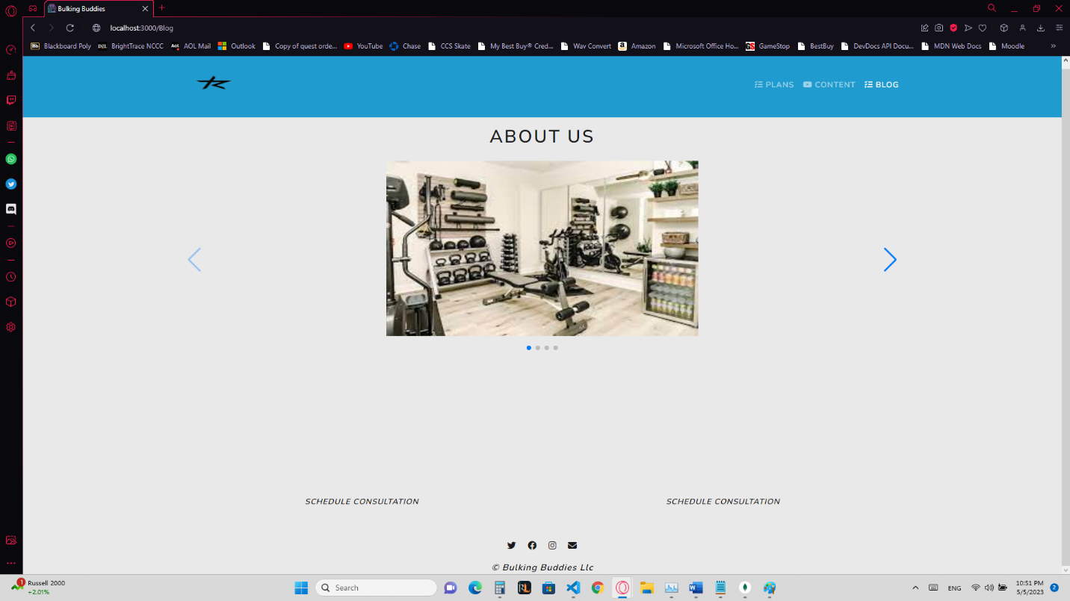

# Discussion

I learned a lot about Redux and the importance of gathering state information. Redux allows you to simply maintain user data as they navigate through the site. This can make keeping track of the customers information along with a plan they may be interested in easier as you can manage it all through Redux.

Creating responsive pages that adjust based on the user’s device went very well along with creating components and routes. On the other hand, Both the Axios Crud operations and payment API have been very difficult to implement and may require more tie than initially intended for this project.

I believe having stronger resources to access would have been beneficial. In this case I was using some documentation along with an outdated e commerce course to create my page. The problem with this is that as frameworks age their methods begin to become deprecated which in turn changes what you can and cannot use along with how they affect other pieces of your code.

# Conclusion and Future Work

During this project I was able to create a personal fitness page that is essentially ready for deployment. The desired customization has been completed on the frontend, and all that is left is to complete the payment processor. In the coming weeks I plan to implement Stripes payment processing API which will allow users a secure checkout and act as a way for the business owner to manage active members. In the content page I will plan to implement filtering of the content loaded to the page instead of routing to different components as filtering already rendered content will decrease load time and reduce application weight at the same time. I also plan to add a complete scheduling API that will allow customers who have purchased a plan the option to see the trainer’s availability and choose a time that works best for them.

# References

[1] https://www.simplilearn.com/tutorials/nodejs-tutorial/what-is-express-js

[2] https://legacy.reactjs.org

[3] https://nodejs.org/en/about

[4] https://www.mongodb.com/what-is-mongodb

[5] https://stackoverflow.com/questions/71270157/what-is-the-index-html-file-used-for-in-react#:~:text=public%2Findex.,be%20managed%20by%20React%20DOM.

# Appendix

Mongo DB:

1. Create an account, download, or use online cloud version of database, <https://www.mongodb.com>
2. Obtain API key, in this case the copy is the mongo URI is stored in the .env file in the root directory of the project.

Node:

1. Install node on your device

<https://fastdl.mongodb.org/windows/mongodb-windows-x86_64-6.0.5.zip>

React:

1. Open your text editor’s terminal and enter npx create-react-app

The best way to get this project up and running would be to copy and paste the following dependencies to your “package.json” file open your text editor’s terminal and navigate to each package.jsons directory. You can then enter “npm I” to install them all at once

The Root Package.json’s dependencies are as follows:

    "cors": "2.8.5",

    "dotenv": "^16.0.3",

    "express": "^4.18.2",

    "express-async-handler": "^1.2.0",

    "mongoose": "^7.0.2",

    "node-fetch": "^3.3.1",

    "save": "^2.9.0",

    "uuid": "^9.0.0"

The Front end Package.json’s dependencies are as follows:

"@fortawesome/fontawesome-svg-core": "^6.4.0",

    "@fortawesome/free-regular-svg-icons": "^6.4.0",

    "@fortawesome/free-solid-svg-icons": "^6.4.0",

    "@fortawesome/react-fontawesome": "^0.2.0",

    "@paypal/react-paypal-js": "^7.8.3",

    "@reduxjs/toolkit": "^1.9.3",

    "@testing-library/jest-dom": "^5.16.5",

    "@testing-library/react": "^13.4.0",

    "@testing-library/user-event": "^13.5.0",

    "axios": "^1.3.4",

    "babel-plugin-macros": "^3.1.0",

    "bootstrap": "^5.2.3",

    "react": "^18.2.0",

    "react-bootstrap": "^2.7.2",

    "react-dom": "^18.2.0",

    "react-icons": "^4.8.0",

    "react-redux": "^7.2.9",

    "react-responsive-carousel": "^3.2.23",

    "react-router-bootstrap": "^0.26.2",

    "react-router-dom": "^6.8.1",

    "react-scripts": "5.0.1",

    "redux": "^4.2.1",

    "redux-devtools-extension": "^2.13.9",

    "redux-thunk": "^2.4.2",

    "swiper": "^9.1.0",

Git hub repository: https://github.com/spainh/PF-Training